Tiling Problem

Given a “2 x n” board and tiles of size “2 x 1”, count the number of ways to tile the given board using the 2 x 1 tiles. A tile can either be placed horizontally i.e., as a 1 x 2 tile or vertically i.e., as 2 x 1 tile.
Let “count(n)” be the count of ways to place tiles on a “2 x n” grid, we have following two ways to place first tile.
- If we place first tile vertically, the problem reduces to “count(n-1)”
- If we place first tile horizontally, we have to place second tile also horizontally. So the problem reduces to “count(n-2)”
Therefore, count(n) can be written as below.
count(n) = n if n = 1 or n = 2
count(n) = count(n-1) + count(n-2)

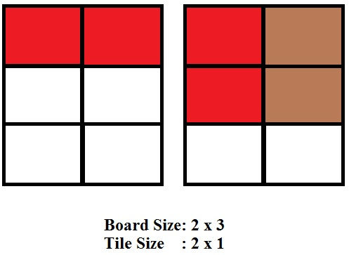

The recurrence is similar to Fibonacci.

Count the number of ways to tile the floor of size n x m using 1 x m size tiles
Given a floor of size n x m and tiles of size 1 x m. The problem is to count the number of ways to tile the given floor using 1 x m tiles. A tile can either be placed horizontally or vertically.
Both n and m are positive integers and 2 < = m.
Examples:
Input : n = 2, m = 3
Output : 1
Only one combination to place two tiles of size 1 x 3 horizontally on the floor of size 2 x 3.

Input : n = 4, m = 4
Output : 2
1st combination:
All tiles are placed horizontally
2nd combination:
All tiles are placed vertically.

We are basically starting with the first row.
You can either fill it with a single 1 x M block or put an M x M block(collection of m rows) giving the terms count(n-1) and count(n-m) respectively.

| 1, 1 < = n < m
count(n) = | 2, n = m
| count(n-1) + count(n-m), m < n

int countWays(int n, int m){
// table to store values of subproblems
int count[n + 1];
count[0] = 0;

// Fill the table upto value n
for (int i = 1; i <= n; i++) {
if (i > m)
count[i] = count[i - 1] + count[i - m];
// base cases
else if (i < m)
count[i] = 1;
// i = = m
else
count[i] = 2;
}

// required number of ways
return count[n];
}

